**Bond Mega-Trades**

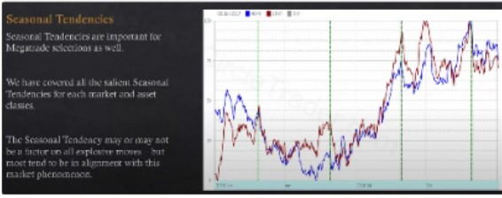

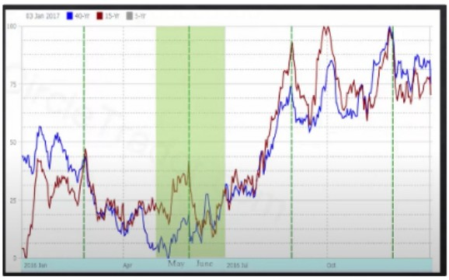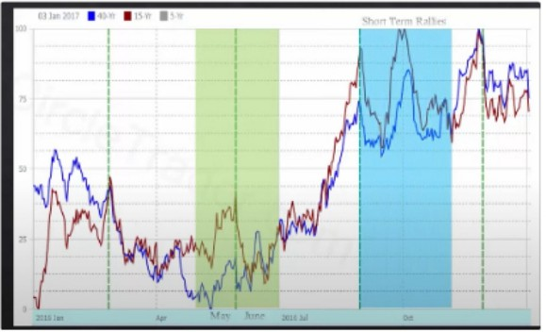

30 year bond seasonal tendencies

During may and june is the best setup for megatrades

I 111 \'I\ •, I I<' 11 \ ',\I I



***e Day's***

***change***

**15 ,o**

**BONDS**

ThTereasury Bond Market is routinelv a

"Trending" Market historically.

When seeking Megatrades in Bonds it is crucial to refer to the 5 Year, IO Year Notes comparably with the 30 Year Bond l\farket.

This ,11111Iic,1ti,1n of "Rcl.itiVL' Strength"

,\11.11\sis \\ill ,11d Ill t1m1llg \\hl'll till' Sm,nt \1,Hll'\ ,Ktu,lih SIL'!'' 111 ,llld Hms thL· 1;,,lld \LnkL'I Ill l.11gL' 111,1g111tu,k

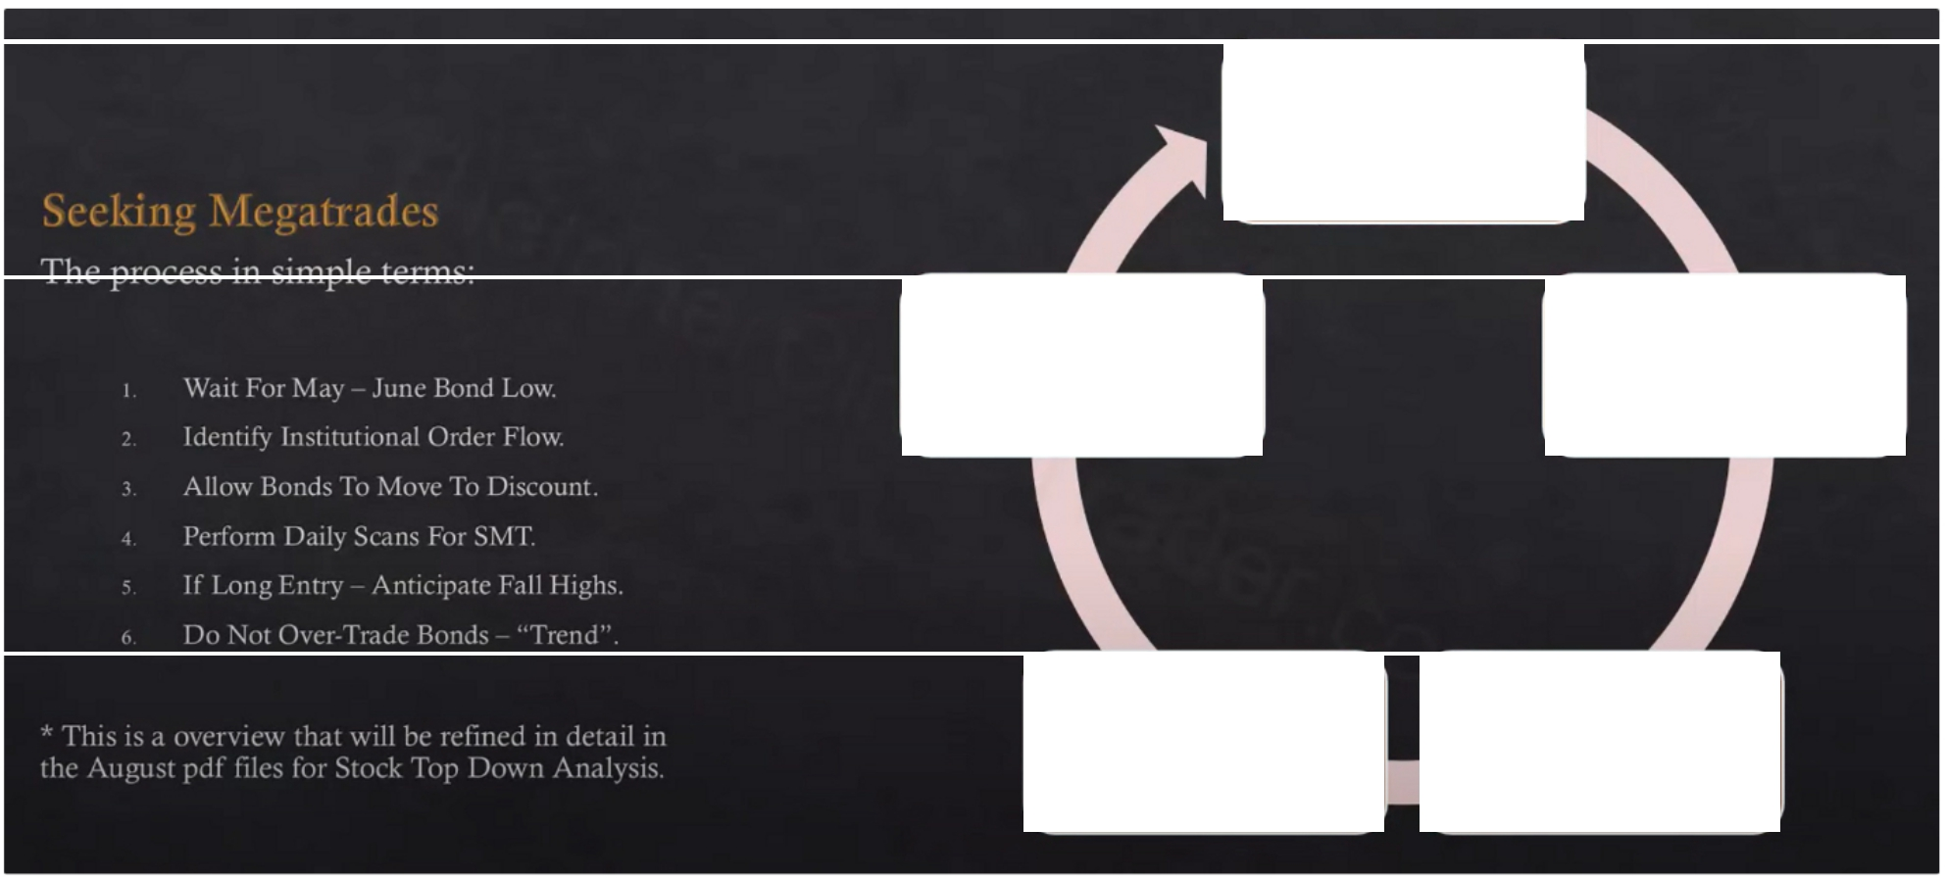

**Seasonal**

**Spring/Summer**

Fall Highs Then

Short Term Trading Begins

Wait ForHTF

Institutional PDA

Hunt Interest

Rate SMT

Bond Market

In Discount

If we get a trending bond that will allow other asset classes to trend as well

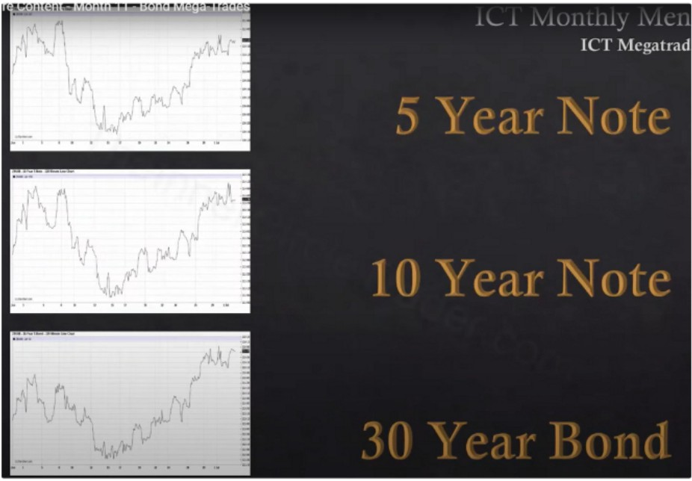 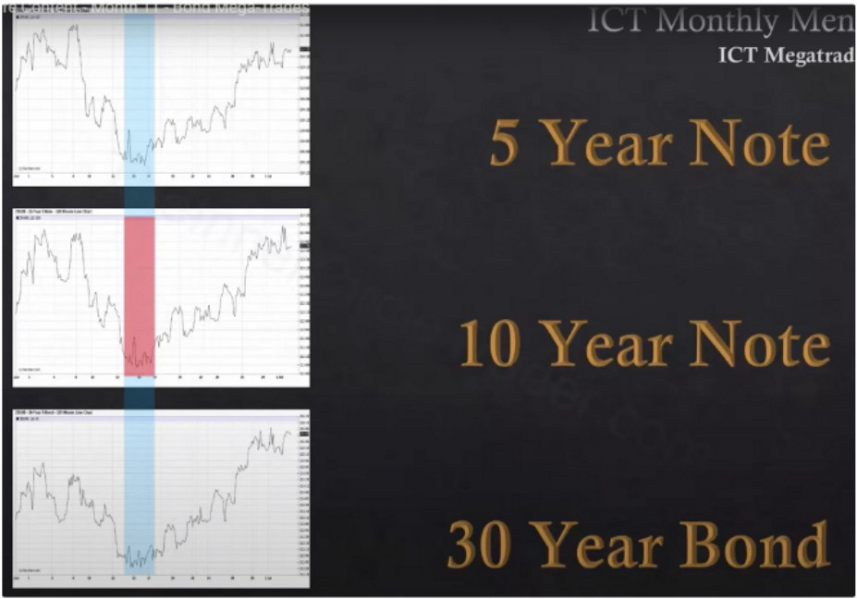

There has to be SMT, a crack in correlation 30 year yield is long term

10 year yield is intermediate term 5 year yield is short term

ICT uses daily and 2h chart

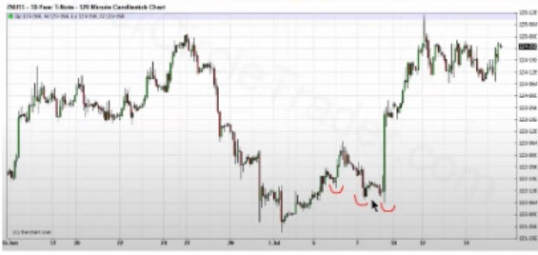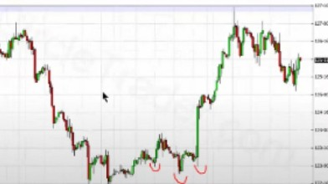I §

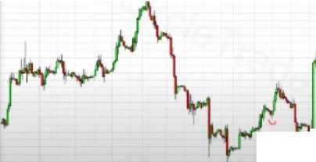

F

ft,'VI

I

*v�*

,. '· - -

Using 3 points of reference, a little bit different interpertation but same result

September october we look for the highs to be formed

No megatrade in 2013, kept making lower lows and no SMT 2012 also no mega trade

Bonds typically dont have a lot of manipulation Every full handle is 1k dollars per contract

1Ok or more dollars is qualified as a mega trade for the bond market

Arjo I Twitter, lnstagram I Linktree

Linktree. Make your link do more.

1 https://t.co/HhmmTN1fUI

JavaScript is not available.

https://twitter.com/arjoio